Course Name | Heartsaver Bloodborne Pathogens Training
Type | This course involves a classroom session or skills check  There is no classroom session (e.g., online course)
Discipline | Heartsaver
Course Image | 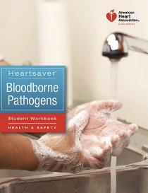
CEU Credits | 1.0
Description | Heartsaver Bloodborne Pathogens Course is a classroom course that teaches employees how to protect themselves and others from being exposed to blood or blood-containing materials. This course is designed to meet Occupational Safety and Health Administration (OSHA) requirements for bloodborne pathogens training when paired with site-specific instruction.  Additional Info: Students will receive a certificate of completion from the American Heart Association valid for two (2) years. All requirements for this class will be completed at the time of the course (1 HR).  This course is designed for anyone with a reasonable chance of coming into contact with bloodborne pathogens such as:  • Correctional Officers  • Childcare workers  • Security guards  • Maintenance workers  • School personnel  • Hotel housekeepers  • Health and fitness club staff  • Tattoo artists
Confirmation Email | Thank you for registering your attendance for our American Heart Association's Heartsaver CPR AED Classroom Course. We look forward to helping you achieve your safety and CPR goals.  This serves to confirm your registration for the upcoming CPR AED Course. Should you have any questions, please let us know. We look forward to seeing you soon!

Course Name | Heartsaver Pediatric First Aid CPR AED
Type | This course involves a classroom session or skills check
Discipline | Heartsaver
Course Image | 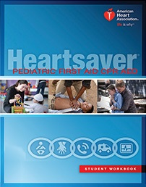
CEU Credits | 3
Description

Confirmation Email

Course Name | Heartsaver® CPR AED
Type | This course involves a classroom session or skills check
Discipline | Heartsaver
Course Image | 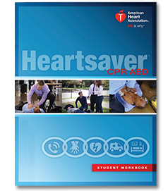
CEU Credits | 2
Description | Is this course for me? Please note that if you are a healthcare provider or healthcare student who requires CPR certification then this course will not fulfill your requirements. Register for the Basic Life Support for Healthcare Providers course to meet your requirements.  The Heartsaver CPR/AED Course teaches adult, child and infant CPR and relief of choking as well as use of barrier devices. Students also get hands-on training with an Automated External Defibrillator (AED).  Additional Info:  - This is an American Heart Association course  - Your Heartsaver CPR AED student workbook is included for free with the cost of your registration (no additional charge)  - You will receive a certificate of completion from Trio Safety as well as your AHA certification card
Confirmation Email | Thank you for registering your attendance for our American Heart Association's Heartsaver CPR AED Classroom Course. We look forward to helping you achieve your safety and CPR goals.  You will receive your CPR card via email using the AHA eCard system. Your course completion card will be valid for a period of two (2) years from the date of your class.  This serves to confirm your registration for the upcoming CPR AED Course. Should you have any questions, please let us know. We look forward to seeing you soon!

Course Name | Heartsaver® First Aid
Type | This course involves a classroom session or skills check
Discipline | Heartsaver
Course Image | 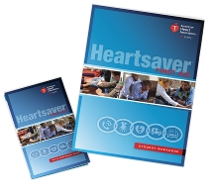
CEU Credits | 3
Description | This course is designed for Teachers, Coaches, Babysitters, Construction workers, and the general public. This classroom course includes essential information and training in the first-aid skills recommended by OSHA, all in a format that can be delivered in a single day. The course is modular to meet the needs of a specific workplace or group of employees. The core module comprises general principles, medical emergencies and injury emergencies.
Confirmation Email | Thank you for registering your attendance for our American Heart Association's Heartsaver First Aid Classroom Course. We look forward to helping you achieve your safety and CPR goals.  You will receive your CPR card via email using the AHA eCard system. Your course completion card will be valid for a period of two (2) years from the date of your class.  This serves to confirm your registration for the upcoming First Aid Course. Should you have any questions, please let us know. We look forward to seeing you soon!

Course Name | Heartsaver® First Aid CPR AED
Type | This course involves a classroom session or skills check
Discipline | Heartsaver
Course Image | 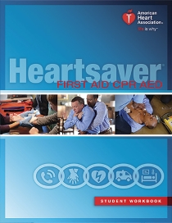
CEU Credits | 5
Description | This course is designed for Teachers, Coaches, Babysitters, Construction workers, and the general public. This classroom course includes essential information and training in the first-aid skills recommended by OSHA as well as CPR and AED certification training - all in a format that can be delivered in a single day. The course is modular to meet the needs of a specific workplace or group of employees. The core module comprises general principles, medical emergencies and injury emergencies.
Confirmation Email | Thank you for registering your attendance for our American Heart Association's Heartsaver First Aid CPR AED Classroom Course. We look forward to helping you achieve your safety and CPR goals.  You will receive your CPR card via email using the AHA eCard system. Your course completion card will be valid for a period of two (2) years from the date of your class.  This serves to confirm your registration for the upcoming First Aid CPR AED Course. Should you have any questions, please let us know. We look forward to seeing you soon!

Course Name | Advanced Cardiovascular Life Support (ACLS)
Type | This course involves a classroom session or skills check
Discipline | ACLS
Course Image | 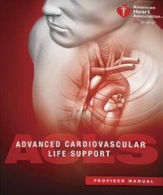
CEU Credits | 10
Description | American Heart Association ACLS Certification - 2 Year Certification  Recommended for: All healthcare professionals and medical personnel who may respond to a cardiovascular emergency as part of a team involved in the administration of cardiac drugs.  The ACLS Class covers:  - Recognition and early management of respiratory and cardiac arrest  - Airway Management  - ACLS Pharmacology  - Basic Life Support (BLS) review  - Management of acute coronary syndromes and stroke  - How to be both a leader and a team member in a resuscitation team  EMS, ABN, and Pharmacy CEs Available!  This course lasts approximately eight (8) hours. This class is a one-day course.
Confirmation Email | STUDENTS MUST COMPLETE THE ACLS PRE-COURSE ASSESSMENT, AND PRINT/BRING THEIR CERTIFICATE TO CLASS: https://ahainstructornetwork.americanheart.org/AHAECC/ecc.jsp?pid=ahaecc.studentlanding Use code acls15 to log into the course.  ___________________________________________  FAQS  Here are some answers to common questions we receive about this certification:  Certification: You will be certified by the American Heart Association in Advance Cardiovascular Life Support (ACLS).  Course Completion Card: You will receive your CPR card via email using the AHA eCard system. Your course completion card will be valid for a period of two (2) years from the date of your class.  Class Length: Class length is dependent upon the number and experience levels of the students. On average, our ACLS classes last 7-8 HRS. We will always make sure that all students understand the material and are confident with their skills.

Course Name | Pediatric Advanced Life Support (PALS)
Type | This course involves a classroom session or skills check  There is no classroom session (e.g., online course)
Discipline | PALS
Course Image | 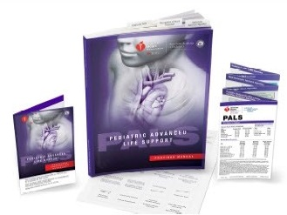
CEU Credits | 8
Description | American Heart Association PALS Provider Certification - 2 Year Certification  Recommended for any healthcare professionals and medical personnel who may respond to pediatric emergencies.  The PALS Class covers:  - High-quality Child CPR AED and Infant CPR  - Recognition of patients who do and do not require immediate intervention  - Recognition of cardiopulmonary arrest early and application of CPR within 10 seconds  - Apply team dynamics  - Differentiation between respiratory distress and failure  - Early interventions for respiratory distress and failure  - Differentiation between compensated and decompensated (hypotensive) shock  - Early interventions for the treatment of shock  - Differentiation between unstable and stable patients with arrhythmias  - Clinical characteristics of instability in patients with arrhythmias  - Post–cardiac arrest management  - The systematic approach to Pediatric Assessment  - Management of pediatric respiratory emergencies  - Vascular access (Including intraosseous training)  - Airway Management  - PALS Pharmacology  - Basic Life Support (BLS) review  - Numerous pediatric case studies and simulations  - How to be both a leader and a team member in a pediatric resuscitation team  This classroom, Instructor-led course uses a series of videos and simulated pediatric emergencies to reinforce the important concepts of a systematic approach to pediatric assessment, basic life support, PALS treatment algorithms, effective resuscitation, and team dynamics. The goal of the PALS Course is to improve the quality of care provided to seriously ill or injured children, resulting in improved outcomes.  For healthcare providers who respond to emergencies in infants and children. This includes personnel in emergency response, emergency medicine, intensive care and critical care units, such as physicians, nurses, paramedics and others who need a PALS course completion card for job or other requirements.  This course lasts approximately eight (8) hours. This class is a one-day course.  All students who successfully complete all requirements will receive their official American Heart Association PALS Provider via email using the AHA eCard system! Your course completion card will be valid for a period of two (2) years from the date of your class.  All students are required to have a current AHA PALS Provider student manual (workbook) during the class day. IF a student arrives at class without a student manual (workbook), they will be required to purchase one for the course or will be rescheduled to a later course.
Confirmation Email | STUDENTS MUST COMPLETE THE ACLS PRE-COURSE ASSESSMENT, AND PRINT/BRING THEIR CERTIFICATE TO CLASS: https://ahainstructornetwork.americanheart.org/AHAECC/ecc.jsp?pid=ahaecc.studentlanding  Use code pals15 to log into the course.  _____________________________________________________________  FAQS  Here are some answers to common questions we receive about this certification:  Certification: You will be certified by the American Heart Association in Pediatric Advanced Life Support (PALS).  Course Completion Card: You will receive your PALS Provider card via email using the AHA eCard system. Your course completion card will be valid for a period of two (2) years from the date of your class.  Class Length: Class length is dependent upon the number and experience levels of the students. On average, our PALS classes last 7-8 HRS. We will always make sure that all students understand the material and are confident with their skills.

Course Name | Basic Life Support (BLS) Providers
Type | This course involves a classroom session or skills check
Discipline | BLS
Course Image | 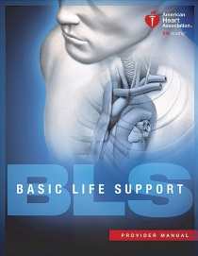
CEU Credits | 4
Description | The BLS Providers course teaches CPR skills for helping victims of all ages, including providing ventilation with a barrier device, a bag-mask device with oxygen, and use of an automated external defibrillator (AED); and relief of foreign-body airway obstruction. Intended for licensed and non-licensed healthcare professionals. Course Length: 3.5-4 hours  This is an American Heart Association course
Confirmation Email | Here are some answers to common questions we receive about this certification:  Certification: You will be certified by the American Heart Association.  Student Manuals: Your student manual will be available at the time of your class.  Course Completion Card: You will receive your CPR card via email using the AHA eCard system. Your course completion card will read "BLS Provider" and will be valid for a period of two (2) years from the date of your class.  Class Length: Class length is dependent upon the number and experience levels of the students. On average, our BLS classes last 3-3.5 HRS. We will always make sure that all students understand the material and are confident with their skills.  We look forward to helping you achieve your safety and CPR goals. This serves to confirm your registration for the upcoming BLS Course.  Should you have any questions, please let us know. We look forward to seeing you at the class. If you have any questions, please feel free to call or email us anytime.

Course Name
Type | This course involves a classroom session or skills check  There is no classroom session (e.g., online course)
Discipline

Price

Course Image
CEU Credits

Description

Confirmation Email

